**Guidelines for Prototype Datasheet**

**I Provide a level 1 block diagram, schematic diagram, flowchart, data flow diagram, and/or comprehensive function list of your block.**

* Make sure that ALL arrows on your block diagram are labeled with enough information that someone reviewing your block diagrams is able to measure the signals/data/power represented by each arrow.
* Label all test point positions.
* Make sure instruments do not obscure the schematic.
* Label all inputs and outputs on the schematic with names that are consistent with the tables below.
* If giving a function list, provide the names, descriptions, inputs, and return values of each function.

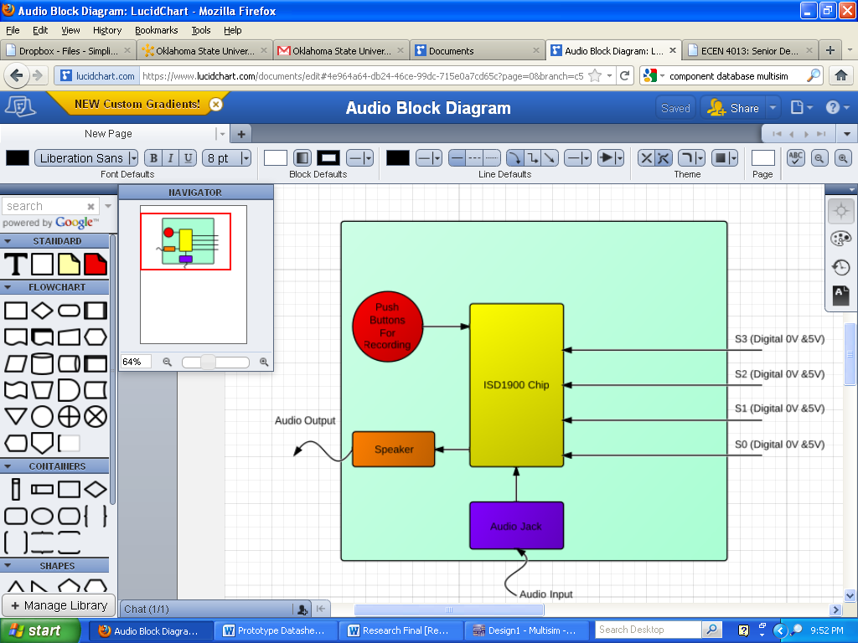

**II List all software and hardware inputs to your block.**

* State the types of signals and the expected ranges of signals entering your block.
* If you are doing code development provide test inputs used to verify functionality. Provide all function names, a description of each function, input parameters, and each function’s return value.
* You may add more lines to these tables as needed. Please expand message boxes as required for detail.

|  |  |  |
| --- | --- | --- |
| Input Name | Description of Signal | Expected Range |
| S0 | When Depressed, Grounds Pin for Sound 1, Causing Sound 1 to output | 5V, 0V: Digital |
| S1 | When Depressed, Grounds Pin for Sound 2, Causing Sound 2 to output | 5V, 0V: Digital |
| S2 | When Depressed, Grounds Pin for Sound 3, Causing Sound 3 to output | 5V, 0V: Digital |
| S3 | When Depressed, Grounds Pin for Sound 3, Causing Sound 3 to output | 5V, 0V: Digital |

**III List the outputs to your block.**

* State the types of signals and the expected ranges of signals leaving your block.
* If you are doing code development please use dummy functions as test outputs. Provide all function names, a description of each function, input parameters, and each function’s return value.
* You may add more lines to these tables as needed. Please expand message boxes as required for detail.

|  |  |  |
| --- | --- | --- |
| Output  Name | Description of Signal | Expected Range |
| Sound 1 | Audio Output – Rebecca Black | ~ 70 dB |
| Sound 2 | Audio Output – Foo Fighters | ~ 70 dB |
| Sound 3 | Audio Output – Nirvana | ~ 70 dB |
| Sound 4 | Audio Output – Sir Mix-A-Lot | ~ 70 dB |

**IV Signals at test points.**

* State the types of signals at each of the test points of your block. Provide a minimum and maximum range for these signals.
* If you are doing code development please use debug statements to test values. Provide locations and the expected values for each of these statements.
* You may add more lines to these tables as needed. Please expand message boxes as required for detail.

**No test points were used.**

**TA Scoring Sheet**

Student Name: ________________________________________

TA Name: ________________________________________

Due Date: _________________________________________

Date Demonstrated: _________________________________

|  |  |  |
| --- | --- | --- |
| **Points Awarded** | **What Evaluator is Looking For** | **Possible Points** |
| ######## | **I Diagrams, flowchart, and/or pseudocode** | **15** |
|  | * Level 1 Block diagram | 5 |
|  | * Inputs and outputs and testpoints clearly labeled? | 5 |
|  | * Is diagram sufficiently detailed and correct? | 5 |
| ######## | **II Inputs** | **15** |
|  | * Are all inputs from block diagram and schematic listed and are values backed up by measured data? | 10 |
|  | * Are inputs measured and graphed/tabulated? | 5 |
| ######## | **III Outputs** | **15** |
|  | * Are outputs from block diagram and schematic listed and are values backed up by measured data? | 10 |
|  | * Are outputs measured and graphed/tabulated? | 5 |
| ######## | **IV Test points** | **15** |
|  | * Are test points from block diagram and schematic listed and are values backed up by measured data? | 10 |
|  | * Are “test points” / “dummy function” graphs/ values given in a manner they can be used for system debugging? Software execution times listed? | 5 |
| ######## | **Overall: System Works** | **40** |
|  | Does the system function as it is supposed to? | 20 |
|  | Does the student have a clear path to correct/improve this block? | 10 |
|  | Is the student knowledgeable about their project? | 10 |
| **_____/100** | **Overall Evaluation** | **100** |

Comments: